**Case Study - Washing machine**

**Name: Vaishnavi Ankar**

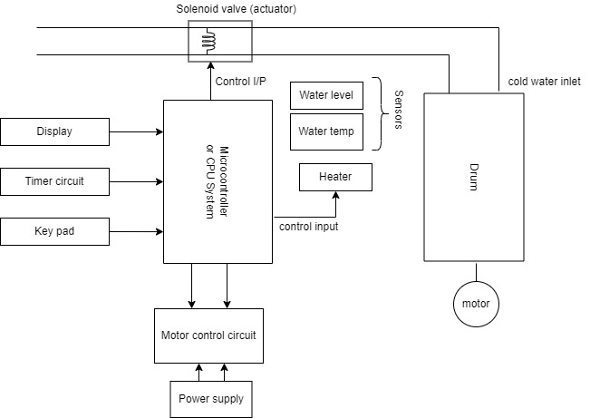

**Block diagram**

**INTRODUCTION:**

* Washing machine provides extensive support in home automation applications. It mainy contains sensors, actuators, control unit and application specific user interfaces like keyboards, display units. LED’s for accepting user’s inputs and providing visual indications.
* These user interfaces are used to find and giving inputs and outputs.
* It contain sensors like water level sensors, temperature sensors, ph sensors, etc.
* Contains actuators like spin and agitators, control motor units. Actuators are the electric pulses that controls any particular devices. eg. Solenoid valves, agitatiors .
* Embedded controllers for controlling the washing operations.
* Sensors, actuators and I/O devices are interfaced to the I/P sub-system of embedded control unit.
* Once you prepare a particular microcontroller for particular task then it cannot be used in any other applications. That means the microcontroller that is used in washing machine cannot be used in any other applications.

**PARTS OF WASHING MACHINE:**

**For input:**

1. **Start Switch-**
2. **Selector Dial-**
3. **Water level sensor-**
4. **Water temperature sensor-**

**For output:**

1. **LED indicators-**
2. **Detergent hatch-**
3. **Drum motor-**
4. **Door lock-**
5. **Water pump-**
6. **Water valve-**
7. **Water heater-**

**OPERATION OF REQUIRED SYSTEM:**

* User selects a wash program on the selector dial
* User press the start switch.
* The door lock is engaged
* The water valves is opened to allow water into the wash drum.
* If the wash program involves detergent, the hatch will open. The detergent hatch will close after the detergent released.
* The water valves will close after ‘full water level’ is sensed.
* The water heater will on when the program involves warm water.
* It will switched of when the water temperature sensor sense the correct temperature.
* Motor will turn on to rotate the drum so that the motor will undergo spin operation to wash cloths. The movements will carried out according to the wash program the user has selected.
* At the end of wash, the motor is stopped.
* The pump is switched on to drain the drum. It will switched of after the drum is empty
* Now the door lock is released
* Various LED’s are used to show that the system is under washing process.